**DAILY ONLINE ACTIVITIES SUMMARY**

|  |  |  |  |  |  |  |  |
| --- | --- | --- | --- | --- | --- | --- | --- |
| **Date:** | **21-05-2020** | | | **Name:** | | **B.A.SOHANKUMAR** | |
| **Sem & Sec** | **4TH SEM A** | | | **USN:** | | **4AL18CS013** | |
| **Online Test Summary** | | | | | | | |
| **Subject** | | **MICRO CONTROLLER AND EMBEDDED SYSTEMS** | | | | | |
| **Max. Marks** | | **30** | | | **Score** | **08** | |
| **Certification Course Summary** | | | | | | | |
| **Course** | **CLOUD FOUNDATIONS** | | | | | | |
| **Certificate Provider** | | | **GREAT LEARNING ACADEMY** | | **Duration** | | **4 .5HOURS** |
| **Coding Challenges** | | | | | | | |
| **Problem Statement:1: 1.Write a c program to create singly linked list(SLL) with n elements and reverse the element using c.**  **Problem Statement 2: . Write a C program to construct a singly linked list by removing duplicate elements in the sorted linked list**  **Problem Statement 3: . Write a C program to implement SRTF process scheduling.** | | | | | | | |
| **Status:Executed** | | | | | | | |
| **Uploaded the report in Github** | | | | | **YES** | | |
| **If yes Repository name** | | | | | **LOCKDOWN CODING** | | |
| **Uploaded the report in slack** | | | | | **YES** | | |

**ONLINE TEST DETAILS:**

Today's online test was on 1st Module of Micro controller and embedded systems (18cs44).The duration of online test was 40 minutes from 10.00am to 10.40am included of 30 questions.The marks obtained by me is 08/30.

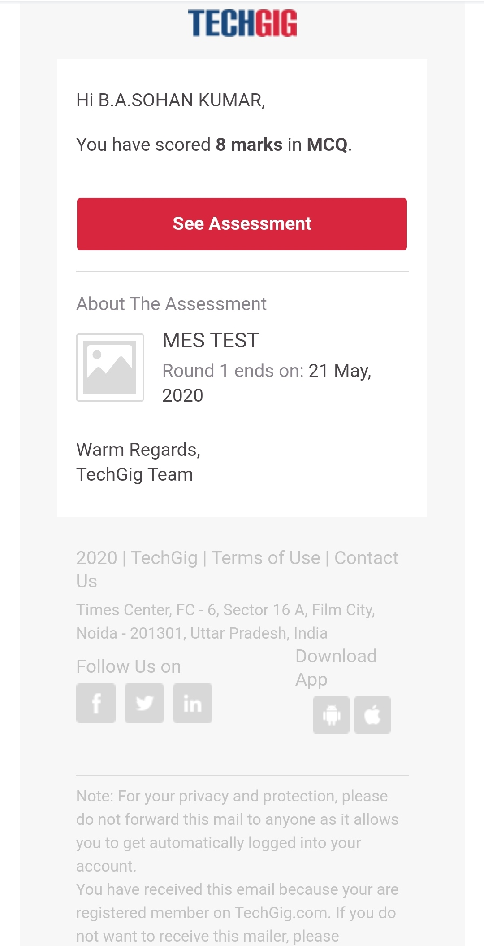

**CERTIFICATION COURSE DETAILS:**

Course Name : Cloud Foundations

Course Objectives:The participants will be introduced to basic concepts of cloud computing.Become familiar with the history and evolution of cloud computing.Understand service, delivery and subscription models.Review the classical enterprise, cloud cost economics and service offerings.

Course Content:History and evolution of cloud,The classical enterprise,Myths of cloudcomputing,Service delivery models,Degree of abstraction,Cloud attributes,Service Offerings,Managed Services,Subscriptions,Cost economics.

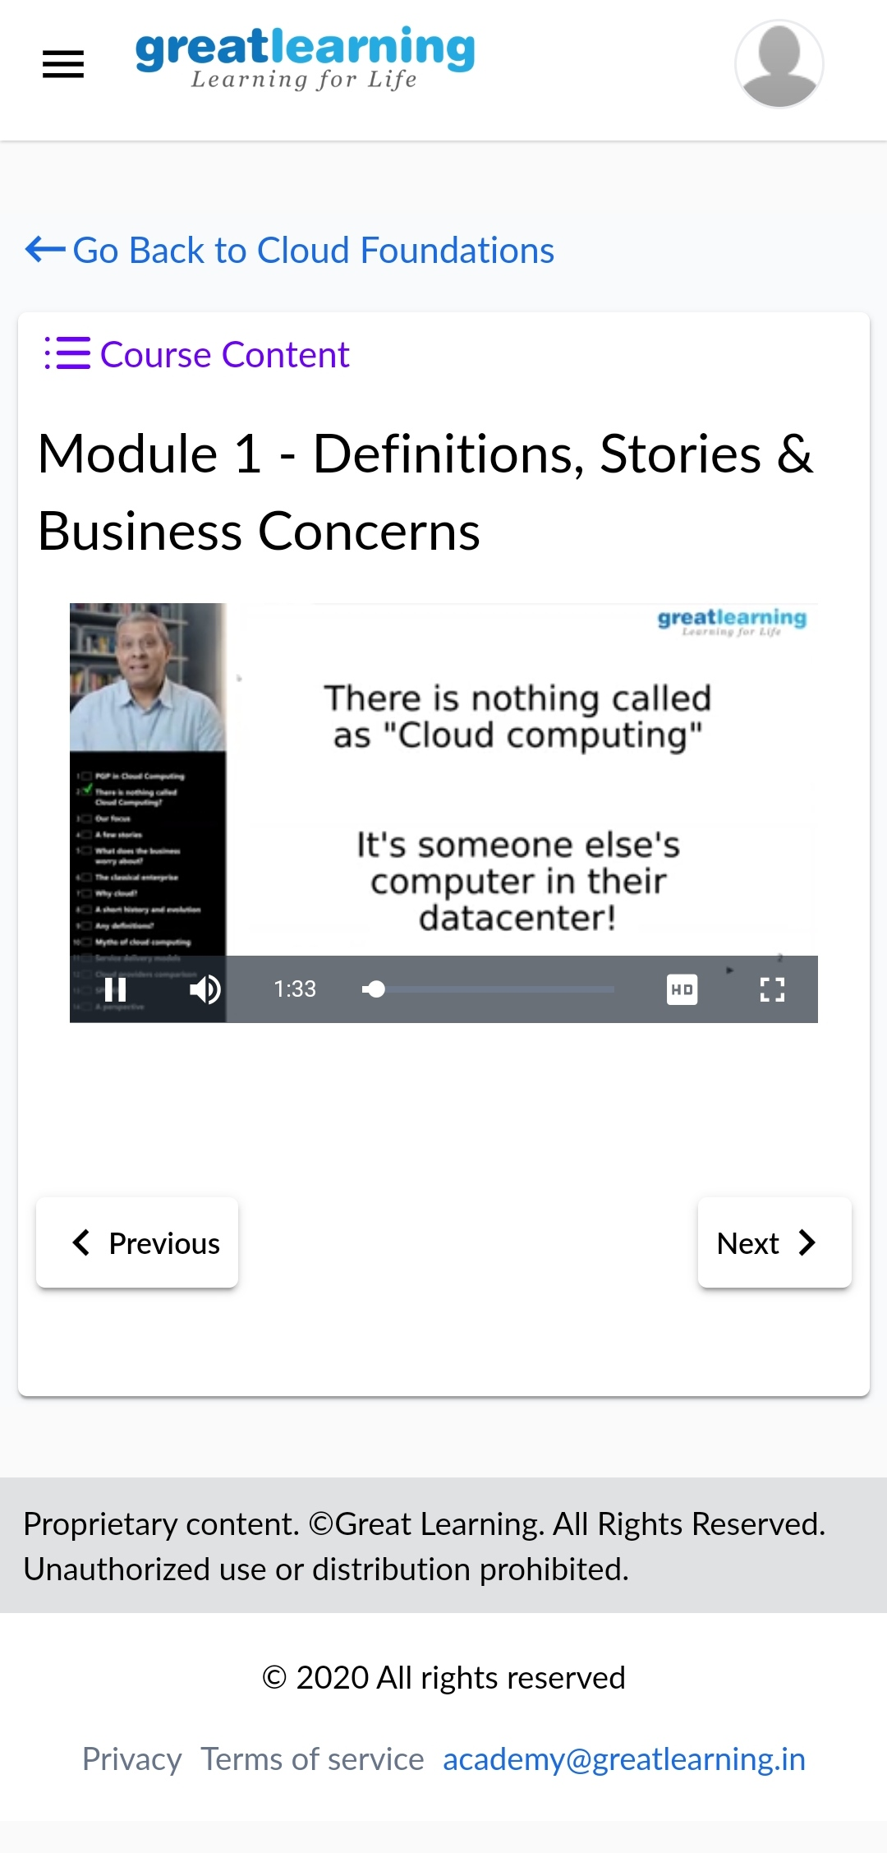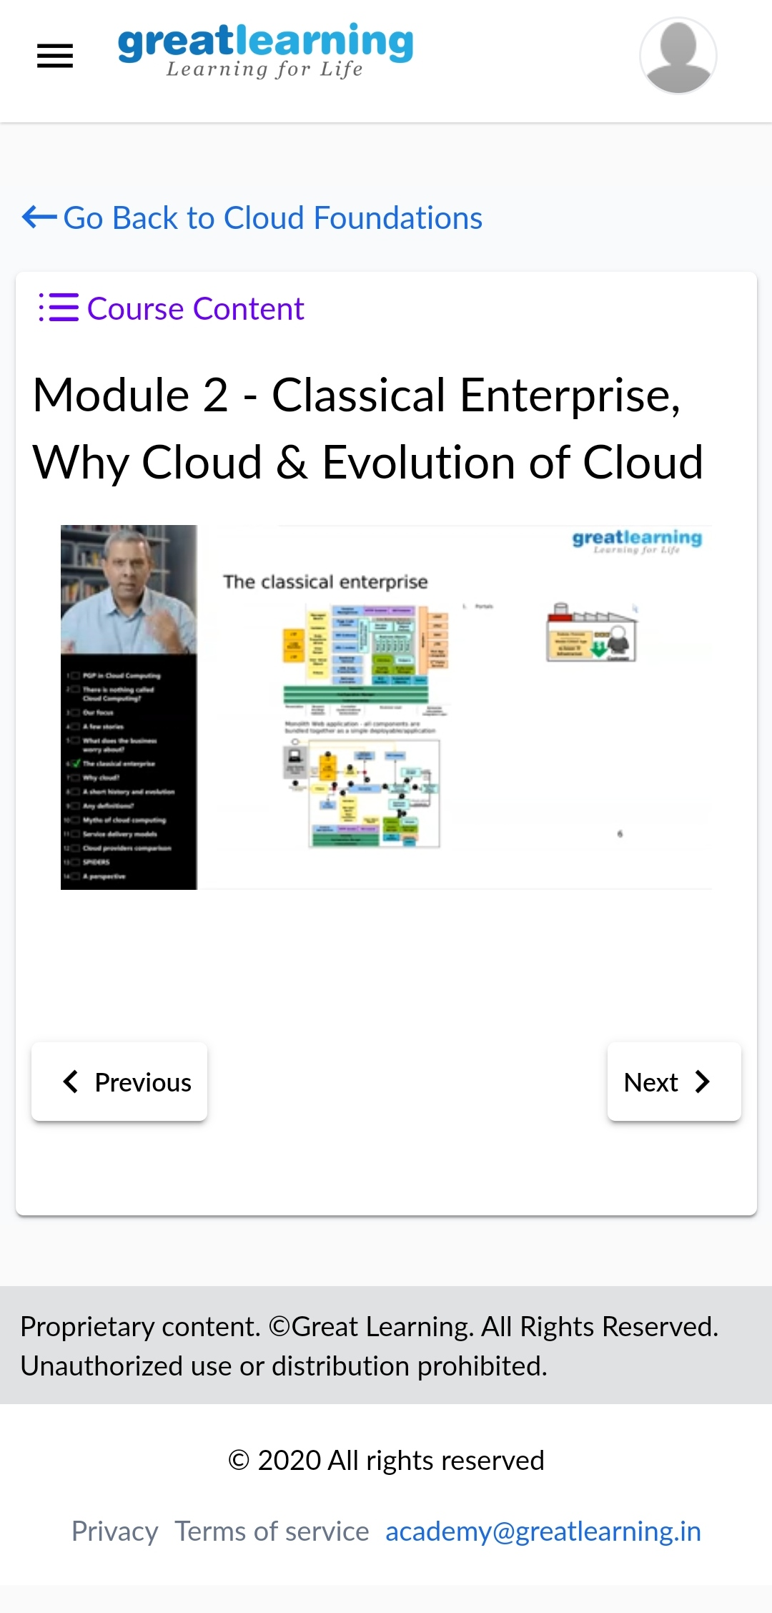**CODING CHALLENGES DETAILS:**

1.Write a c program to create singly linked list(SLL) with n elements and reverse the element using c.

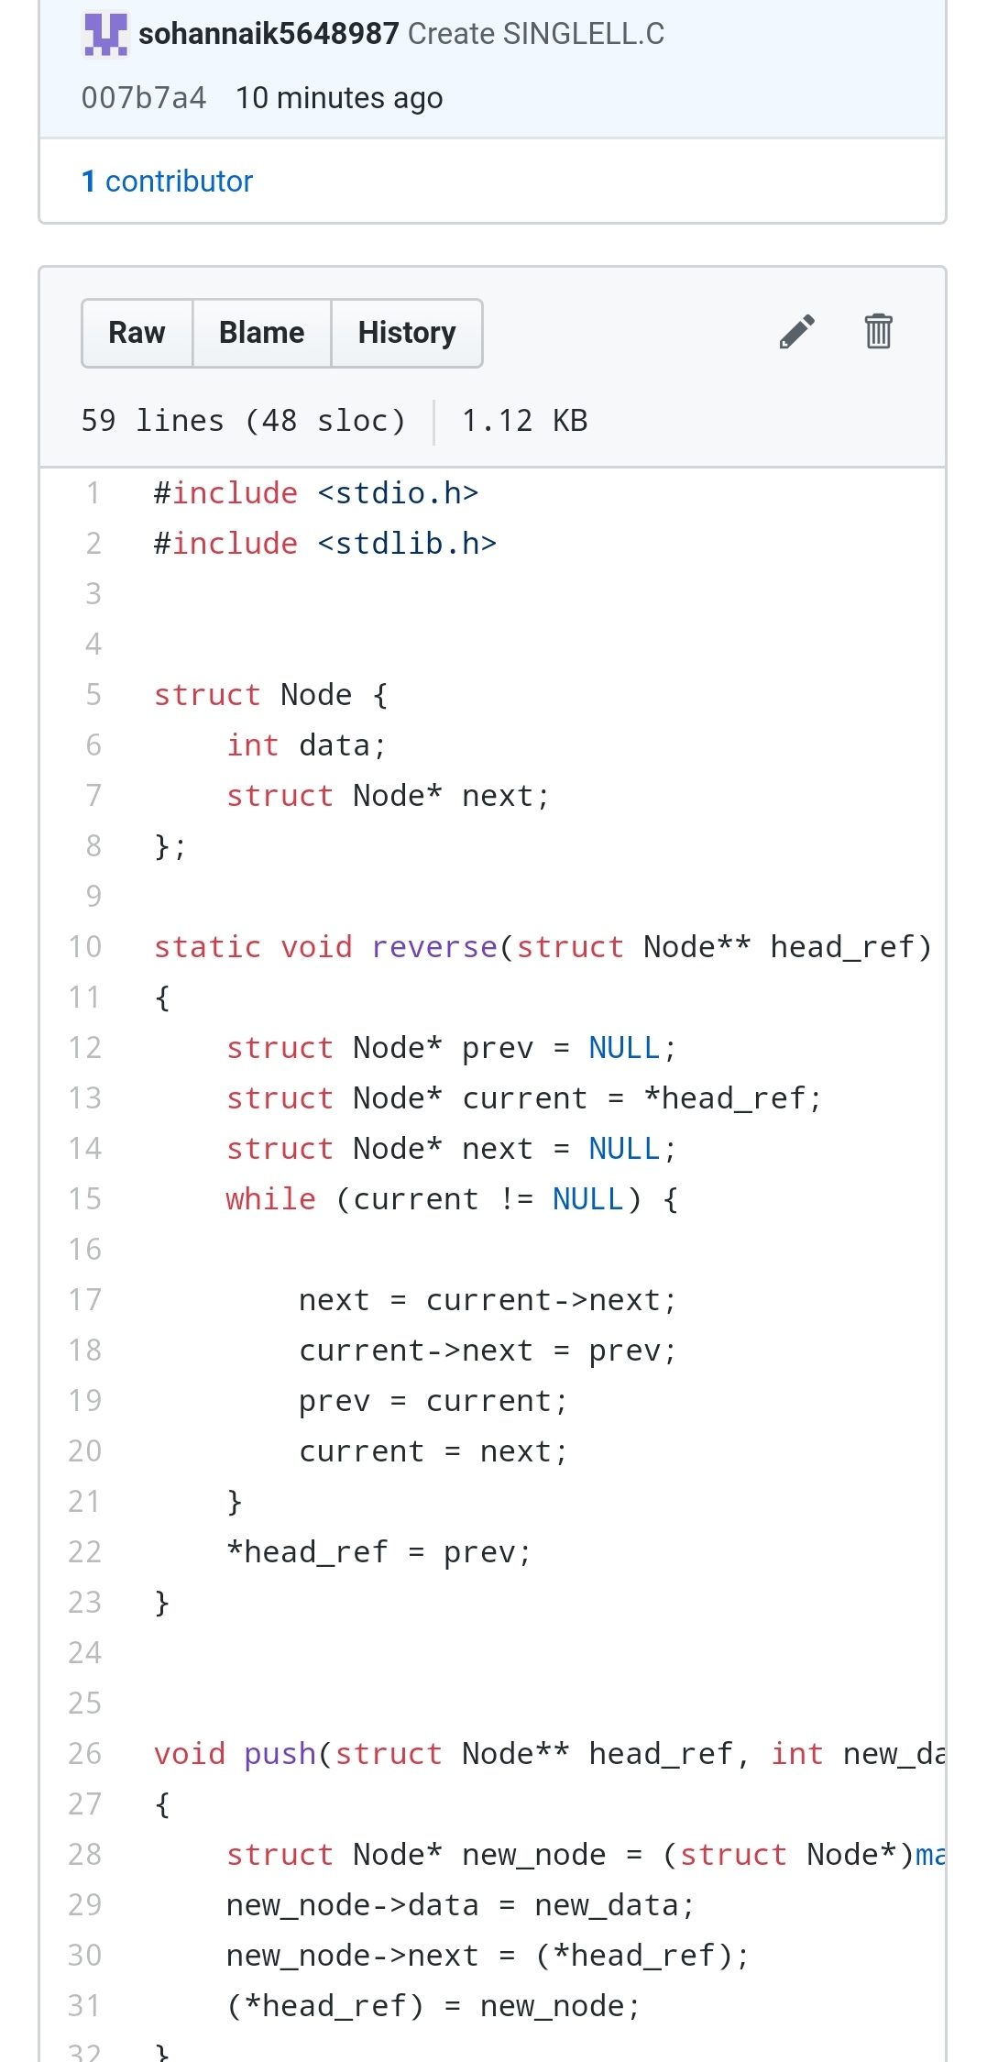

2. Write a C program to construct a singly linked list by removing duplicate elements in the sorted linked list  
Description:  
Take a sorted list and traverse the list. Compare the current node element with next adjacent node. If it is same then delete second element, if not retain. Finally print the resulting list.  
Sample output:Given list {1,2,2,3,3,3,4} Resulting list{1,2,3,4}

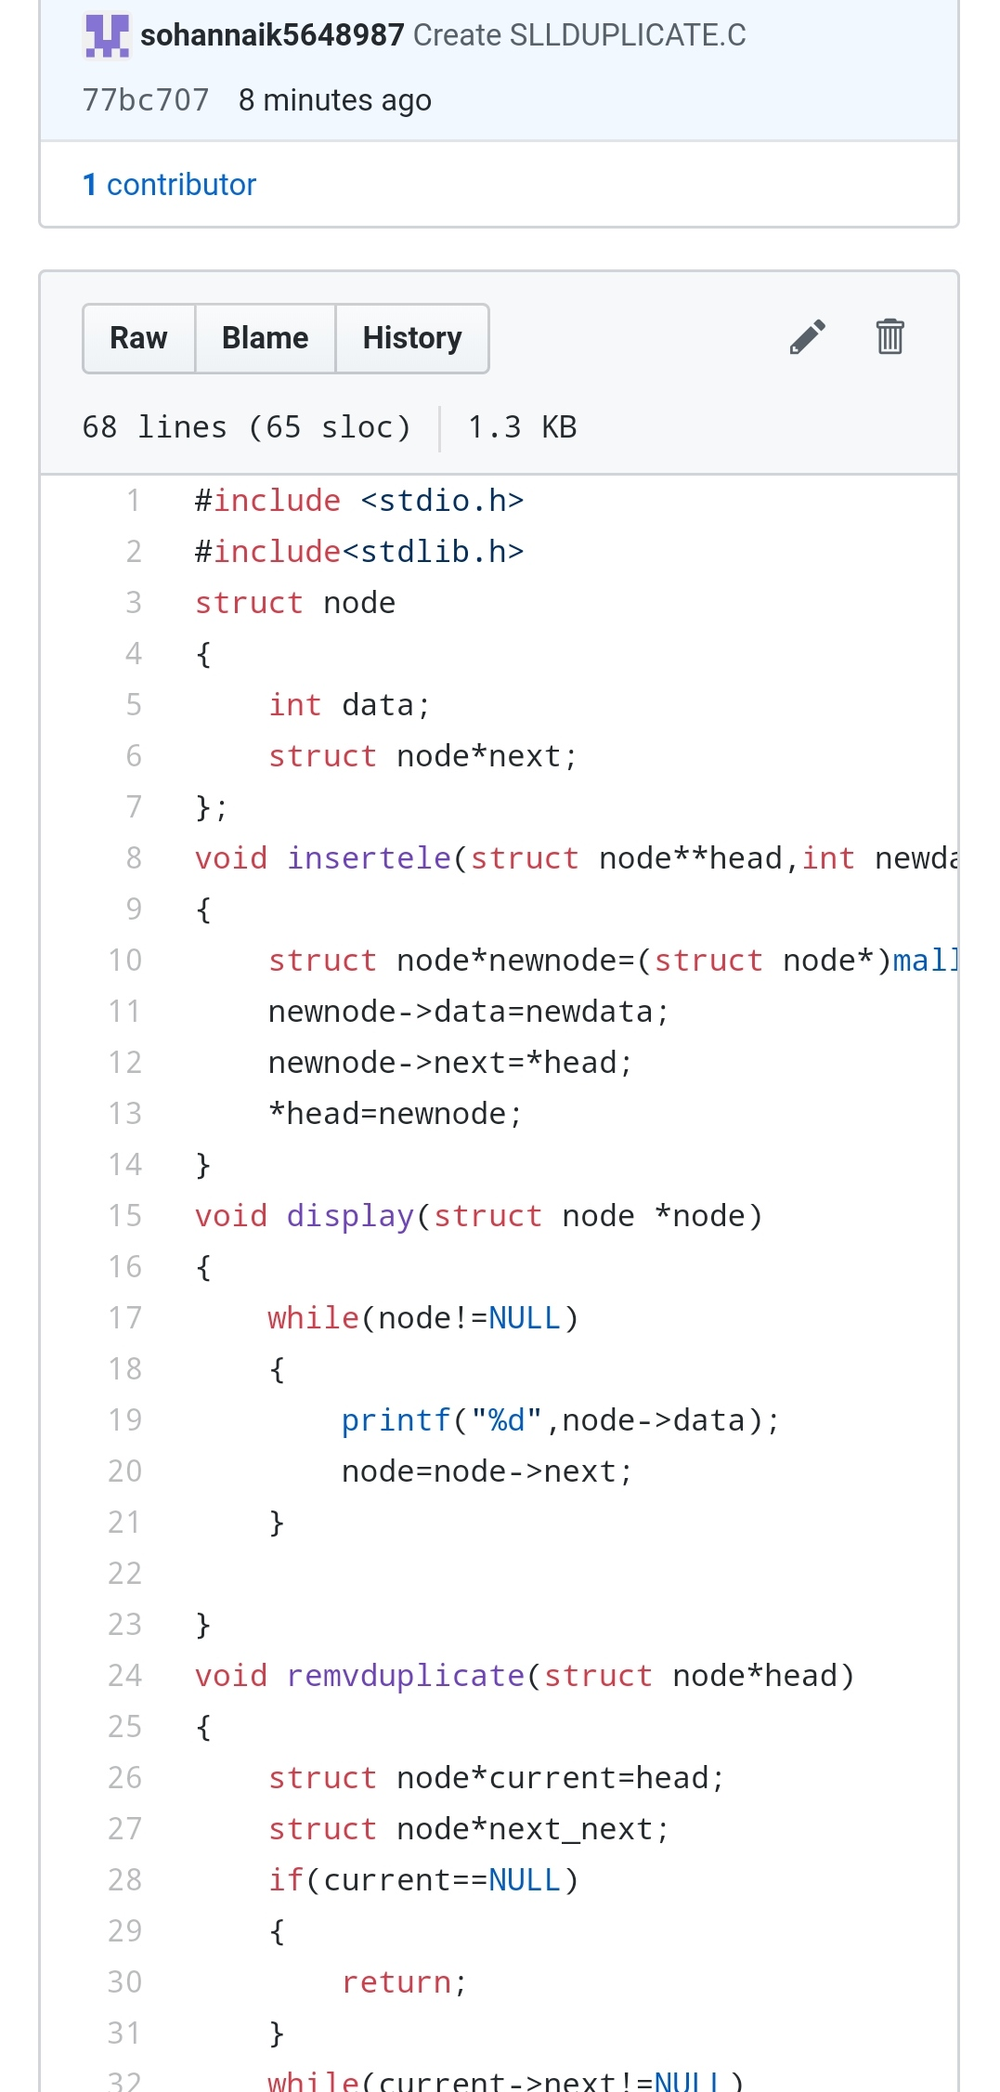

3. Write a C program to implement SRTF process scheduling.  
Input: A set of processes with their burst time and arrival time  
Output: The processes scheduled based on the arrival time and a smaller burst time. 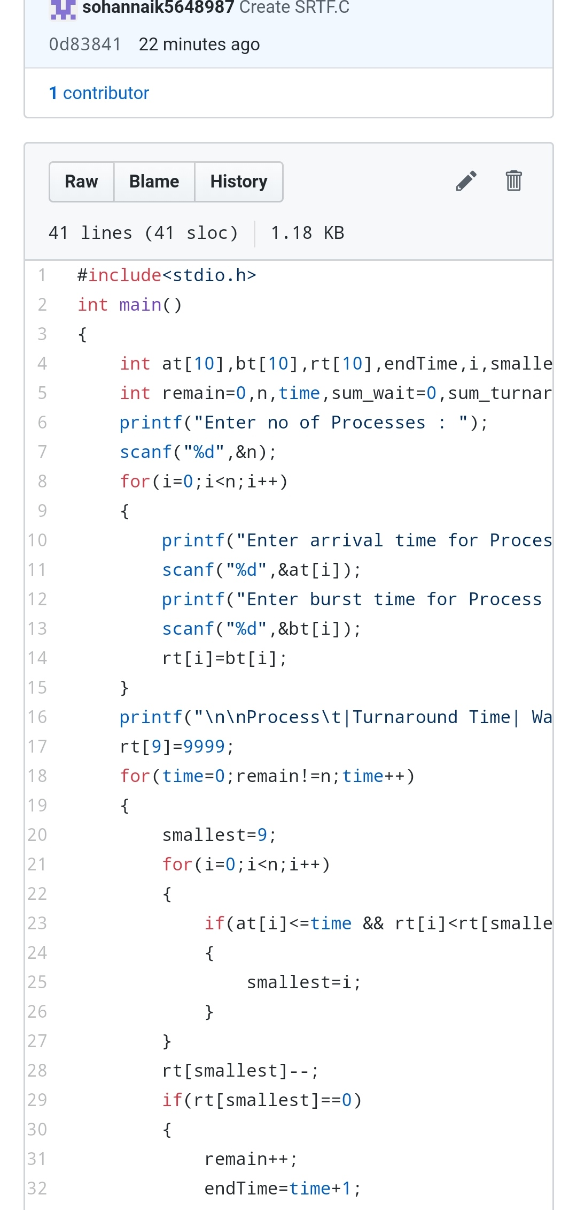

Repository link:https://github.com/sohannaik5648987/lockdown-coding/tree/master